Help your child reach higher!

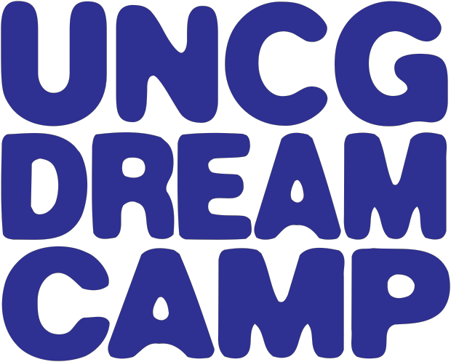

A Day Camp Emphasizing
Social Skills and
Friendship Development
*including but not limited to children/adolescents
with High Functioning Autism

DREAM Camp is a day camp designed for children/adolescents with social skills and friendship challenges, including but not limited to those with High Functioning Autism. Camp is designed for children aged 8 to 18.

DREAM Camp is a therapeutic and recreational summer program. The main focus of the camp is to enhance social and friendship skills. In addition, adolescents will receive developmentally-appropriate life skills training. Campers will also participate in enjoyable camp activities, including arts and crafts, musical performances, and sports!

June 22nd - 26th and July 13th – 17th

Location: UNCG Gateway Research Park in Brown Summit (near Bryan Park)
Transportation: Optional Bus Service will be provided to Campers
Drop Off: UNCG Campus 8:30 a.m.
Pick Up: from UNCG Campus 3:30 p.m.
Cost: $400 per week - $700 for 2 weeks
*Partial needs-based scholarships available!*

We’d like to hear from you. Space is limited to 30 campers per week. If your child is
planning to attend Dream Camp 2015, or if you have questions, please contact
Erin Denio at 336-334-5662. We look forward to a great summer!

