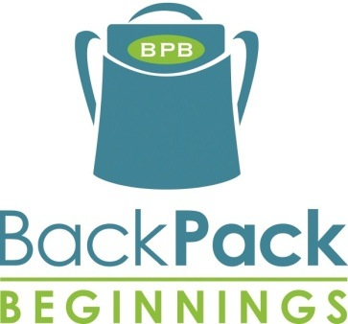ffff

Please show your support and help us feed hungry children in our community by donating non-perishable food items to BackPack Beginnings.

BackPack Beginnings is a 501 (c)(3) non-profit

organization serving over 4,000 children annually.

3707-D Alliance Drive | Greensboro, NC 27407

Serving children in need

…one BackPack at a time

*\*Please do not include items in glass containers or food that*

*has expired.*

Most Needed Items:

* Hearty Soups
* Oatmeal
* Proteins - canned tuna or chicken
* Rice
* Pasta & flavored pasta sides
* Mac–n-cheese
* Beans
* Peanut Butter
* Individual Cereals
* Grits
* Canned Vegetables

# FOOD DRIVE

# For more information visit BackPackBeginnings.Org

# 1 in 4 children

# struggles with hunger

Dates:

June 7th to June 23rd (Round 1)

June 24th to July 14th (Round 2)

July 15th to August 1st (Round 3)

**BOXES LOCATED IN EBERHART LOBBY.**

Contact: Jeni Pathman (t_pathma@uncg.edu)